Positive Pay is a product (an offering) by wholesale banks (like WFB, like SVB Silicon Valley Bank) to prevent misuse of checks.

Imagine that Macys (who banks with Wells Fargo) sends out 2800 paper checks a day to its various vendors. A lot of people in Finance department of Macys have access to these checks. Even a janitor who is cleaning the floor one night may come across a blank check (unsigned) on the A/P manager’s desk. Janitor picks up the check, write it out to his mom “Rashmi Jain” and sign the check as closely as he possibly can to the signature of A/P manager. Gives this check to “Rashmi Jain” and Rashmi deposits it into her account. Check is presented for payment to Wells Fargo and among the 2800 checks that are genuine payments, even this check could possibly clear (because US Banks do not generally match signature a 100% - Alok knows this from personal experience because 5 different people in Canvas sign checks on Alok’s behalf).

This is a problem. These problems are easily caught if this fraud was happening to an individual like “Rohini” because Rohini keeps tab of her account a bit more closely than Macys.

This is where Positive Pay comes in. Each day, Macy’s A/P manager writes out 2800 checks and at the same time creates say an Excel file that has the following outline:
Check# CheckTo CheckAmt CheckDate
123 ABC Network $10,980 10/21/2010
124 Chipotle $3,456.89 10/21/2010
And so on

Now, Macys transmits this “Positive Pay” Excel file to Wells Fargo Bank. Wells Fargo bank keeps it and as and when checks are presented to wells Fargo bank drawn out on Macys, Wells Fargo bank can easily spot a fraudulent check that should not be cashed. So, a check that janitor wrote to “Rashmi Jain” will not be a part of the positive pay file and hence this check will be rejected and an exception report will be sent to Macys that “These items were not honored”.

See how Silicon Valley Bank talks about it:
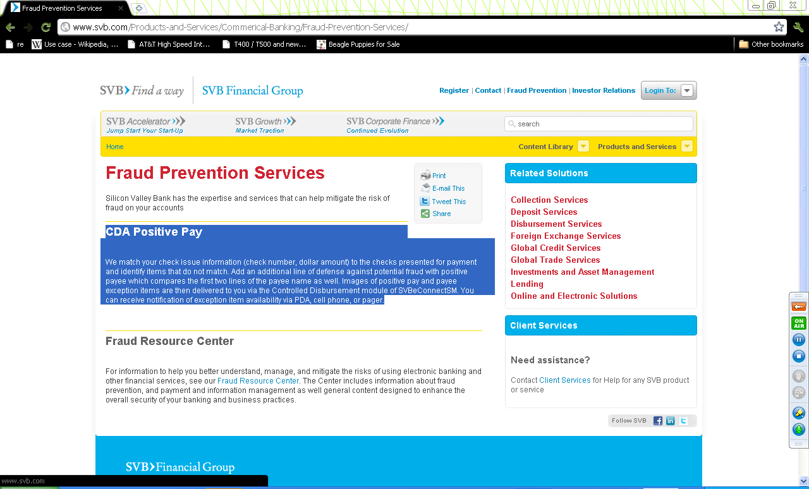

CDA Positive Pay
We match your check issue information (check number, dollar amount) to the checks presented for payment and identify items that do not match. Add an additional line of defense against potential fraud with positive payee which compares the first two lines of the payee name as well. Images of positive pay and payee exception items are then delivered to you via the Controlled Disbursement module of SVBeConnectSM. You can receive notification of exception item availability via PDA, cell phone, or pager.

